ARITHMETIC CALCULATOR USING ANDROID STUDIO

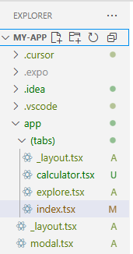

COMMANDS TO RUN VS CODE AND ANDROID STUDIO

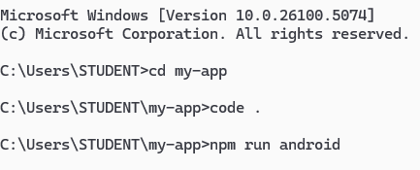

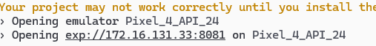

CODE:

import React, { useState } from 'react';
import {
KeyboardAvoidingView,
Platform,
StyleSheet,
Text,
TouchableOpacity,
View,
} from 'react-native';

export default function CalculatorScreen() {
const [display, setDisplay] = useState('');

const append = (value: string) => {
setDisplay((prev) => prev + value);
};

const clearDisplay = () => {
setDisplay('');
};

const calculate = () => {
try {
if (display.includes('^')) {
const [base, exponent] = display.split('^').map(parseFloat);
setDisplay(String(Math.pow(base, exponent)));
return;
}
if (display.includes('++')) {
const num = parseFloat(display.replace('++', ''));
setDisplay(String(num + 1));
return;
}
if (display.includes('--')) {
const num = parseFloat(display.replace('--', ''));
setDisplay(String(num - 1));
return;
}
setDisplay(String(eval(display)));
} catch {
setDisplay('Error');
}
};

return (
<KeyboardAvoidingView
style={styles.container}
behavior={Platform.OS === 'ios' ? 'padding' : undefined}
>
<View style={styles.calculatorBox}>
<Text style={styles.heading}>🧮 Arithmetic Calculator</Text>
<Text style={styles.display}>{display}</Text>

<View style={styles.grid}>
{['7', '8', '9', '/',
'4', '5', '6', '*',
'1', '2', '3', '-',
'0', '.', '%', '+'].map((btn) => (
<TouchableOpacity key={btn} style={[styles.button, styles.number]} onPress={() => append(btn)}>
<Text style={styles.buttonText}>{btn}</Text>
</TouchableOpacity>
))}
<TouchableOpacity style={[styles.button, styles.operator]} onPress={() => append('^')}>
<Text style={styles.buttonText}>^</Text>
</TouchableOpacity>
<TouchableOpacity style={[styles.button, styles.operator]} onPress={() => append('++')}>
<Text style={styles.buttonText}>++</Text>
</TouchableOpacity>
<TouchableOpacity style={[styles.button, styles.operator]} onPress={() => append('--')}>
<Text style={styles.buttonText}>--</Text>
</TouchableOpacity>
<TouchableOpacity style={[styles.button, styles.clear]} onPress={clearDisplay}>
<Text style={styles.buttonText}>C</Text>
</TouchableOpacity>
<TouchableOpacity style={[styles.button, styles.equal]} onPress={calculate}>
<Text style={styles.buttonText}>=</Text>
</TouchableOpacity>
</View>

<Text style={styles.footer}>Designed by Alfiya Shaikh 💖</Text>
</View>
</KeyboardAvoidingView>
);
}
const styles = StyleSheet.create({
container: {
flex: 1,
backgroundColor: '#FFF0F5',
justifyContent: 'center',
paddingHorizontal: 16,
paddingVertical: 24,
},
calculatorBox: {
backgroundColor: '#FFFFFF',
padding: 20,
borderRadius: 18,
elevation: 5,
shadowColor: '#000',
shadowOpacity: 0.1,
shadowRadius: 8,
shadowOffset: { width: 0, height: 4 },
alignItems: 'center',
},
heading: {
fontSize: 22,
fontWeight: '700',
color: '#6A5ACD',
marginBottom: 16,
},
display: {
width: '100%',
fontSize: 24,
backgroundColor: '#FDF5E6',
padding: 10,
borderRadius: 10,
textAlign: 'right',
marginBottom: 16,
color: '#444',
borderWidth: 1,
borderColor: '#D8BFD8',
},
grid: {
flexDirection: 'row',
flexWrap: 'wrap',
justifyContent: 'center',
gap: 8,
},
button: {
width: '22%',
paddingVertical: 12,
margin: 4,
borderRadius: 10,
alignItems: 'center',
},
buttonText: {
fontSize: 18,
fontWeight: 'bold',
color: '#fff',
},
number: {
backgroundColor: '#a1c4fd',
},
operator: {
backgroundColor: '#ff9a9e',
},
clear: {
backgroundColor: '#fbc2eb',
width: '46%',
},
equal: {
backgroundColor: '#c2ffd8',
width: '46%',
},
footer: {
marginTop: 24,
fontSize: 13,
fontStyle: 'italic',
color: '#888',
},
});
